TASK – 2 PORTFOLIO
- GITHUB PROFILE README – LINK –
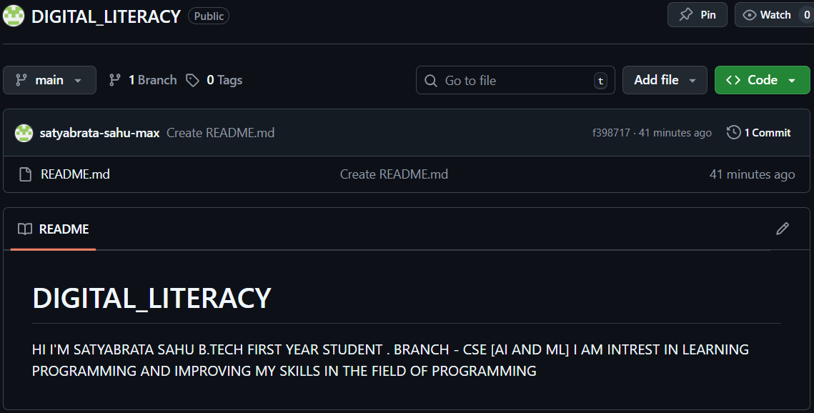
2.LINKEDIN PROFILE –
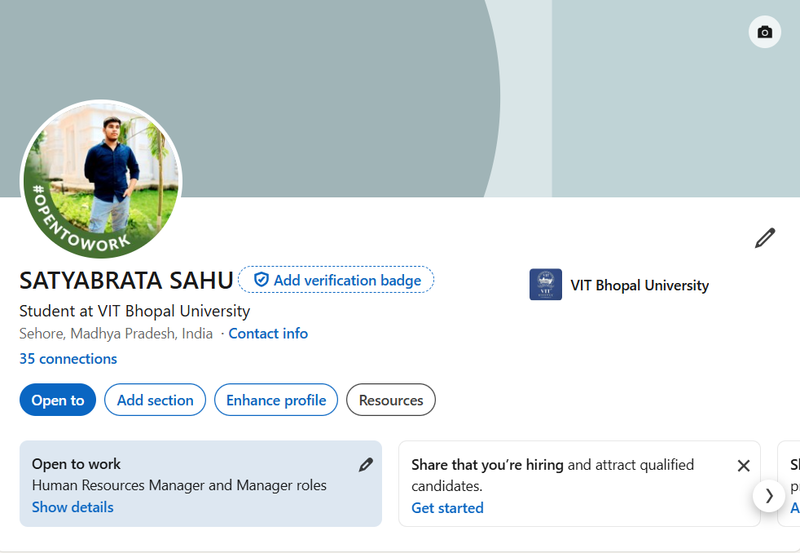
3.HACKERRANK –
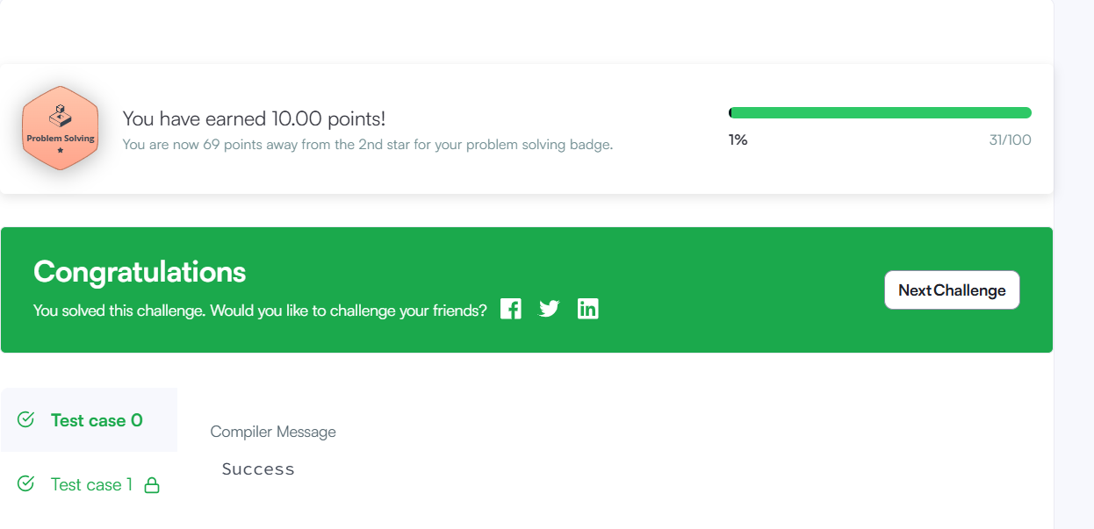
PART B: REPORT WRITE-UP-
For this task, I created my digital portfolio using platforms like GitHub, LinkedIn, and HackerRank. These platforms are very useful for students to build their online presence and improve their skills. GitHub is mainly used to store and showcase projects, LinkedIn helps in creating a professional profile and connecting with others, and HackerRank is useful for practicing coding problems.
While setting up these profiles, I understood how important it is to have a proper digital presence from the beginning of college. I created my GitHub profile and added basic details about myself. On LinkedIn, I filled in my education details and started building a professional profile. I also solved a beginner problem on HackerRank, which gave me some confidence in coding.
In the coming years, I plan to regularly update these platforms by adding my projects, improving my skills, and connecting with professionals. I believe this will help me a lot in internships and future career opportunities.

